Project Report

# ITCS210 - Web Programming - 2016 Section.1C:\Users\NutNNut\AppData\Local\Microsoft\Windows\INetCacheContent.Word\LOGO2.png

# Members

Kittinun Aukkapinyo 5888006  
Sirinut Euaungkanakul 5888046  
Chatchawan Kotarasu 5888084  
Manasanan Sirikulsoonthon 5888162

# Web Accessibility Concerns

Our webpage is easy to use and navigate. Anyone can use our webpage to learn English words through pictures and descriptions.

People with hearing deficiencies can use our site without any problem because our game does not require use of audio, only through picture the user will be able to play. People who have minor eye problem can still navigate at ease because we use simple design with big buttons and easy to understand method of navigation. Blind people however, are not supported.

# Client-Side – HTML, HTML5, CSS, CSS3, Bootstrap, JS, jQuery

* HTML is the basic of web programming and is used on all of our pages for contents and structures.
* HTML5 is used to verify the validity of sign-in and login information. It is also used to make some buttons.

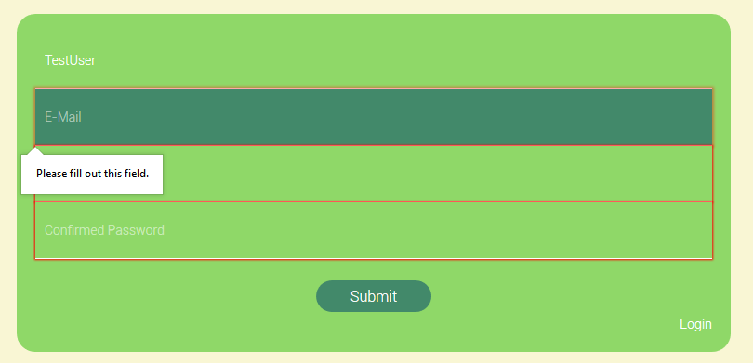

* CSS is used to decorate and position many elements in most of our web pages including the animations.

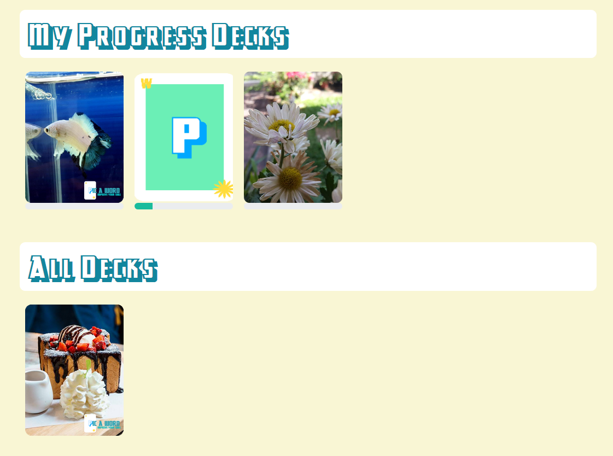

Our main page.

Examples of CSS usage: font, bgcolor, and the images are decorated and positioned with CSS and multiple div elements.

CSS3 is also used in some animations such as fade in and fade out

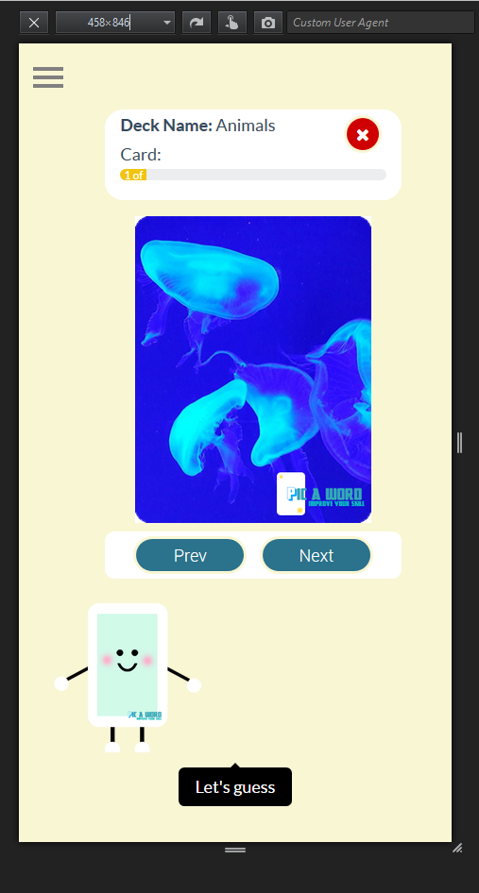

* Bootstrap allow our webpage to have different layouts for use on difference devices or platforms to maximize the experience the user will get on depending on screen sizes.

Vertical Mode

* JS – Most of our pages make use of AngularJS, ranging from showing cards and decks retrieved from Database, to many animations such as progress bar and card flipping. Saving progress on each deck and many game related functions are also written in Angular JS.

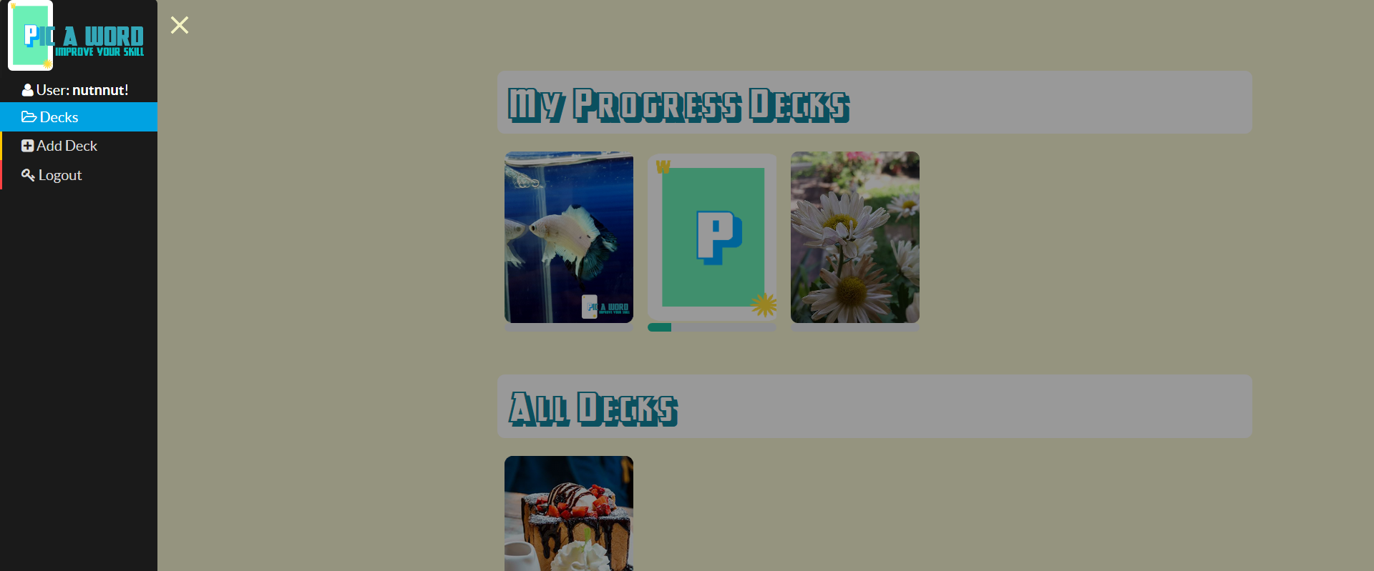

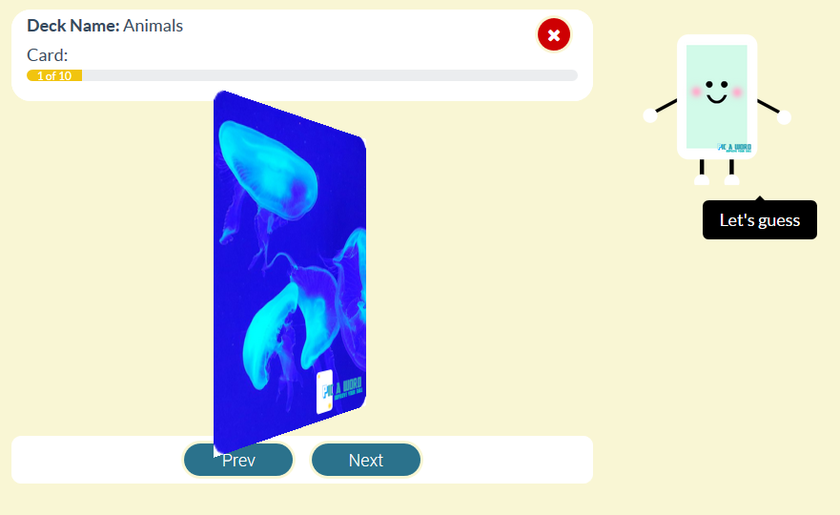

Card Flipping Animation in process. Sidebar

* jQuery is used for dynamic looking of pages and contents such as the pop-up deck information windows when a deck is clicked.

The deck information window when a deck is selected

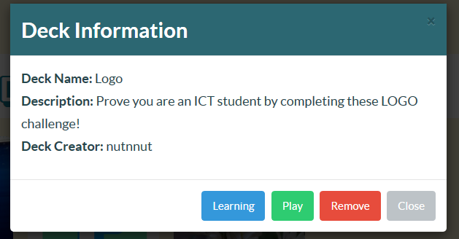

# Server-Side - PHP

PHP is used in our webpage for many essential functions. It is used together with JavaScript to access the database and retrieve decks and cards information. It is used to validate and process sign in, login, and logout requests. Users can also add their own decks and cards, in which PHP is used in the process of uploading and updating our database.

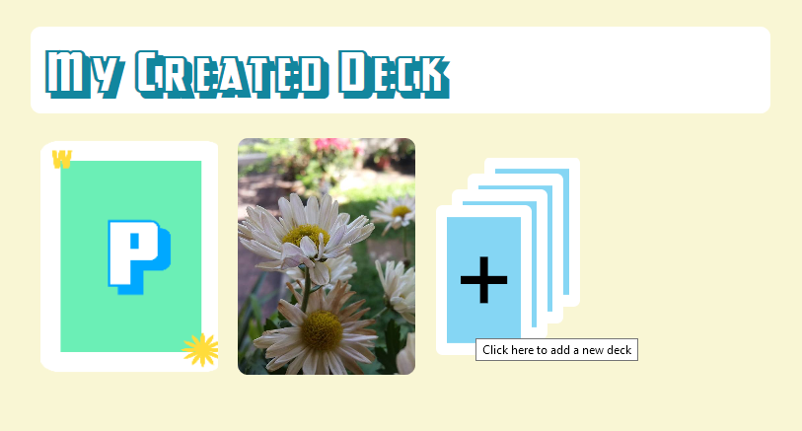

Not only user can play, they can also upload and create their own deck! This system relies on PHP to function.

# C:\Users\NutNNut\AppData\Local\Microsoft\Windows\INetCacheContent.Word\db.png

# Database

Database is used to store many kind of information in our webpage including Cards, Decks, Scores, Rating, Users, and image paths. For ER Diagram, please check the last page.

Each user will have exactly one row in the “**users**” table. The table will store the user’s name, password, and email. A user can have many progress on different decks and a deck also can be played by many users.

The table “**progress**” is created to create M-N relationship between users and deck and also store the progress the user have made.

The table “**deck**” contains all the decks’ name, description, its creator, and the path for cover image. Each deck may contain many cards in it.

the table “**card**” is used to store the word and the description of the card as well as the deck it belongs to. A card can only belong to one deck. The path to the card’s image is also stored to make retrieval of its image possible through JavaScript and PHP.

Partial data from the table “card”

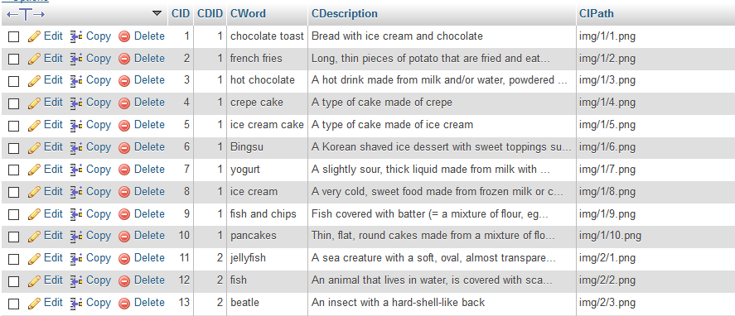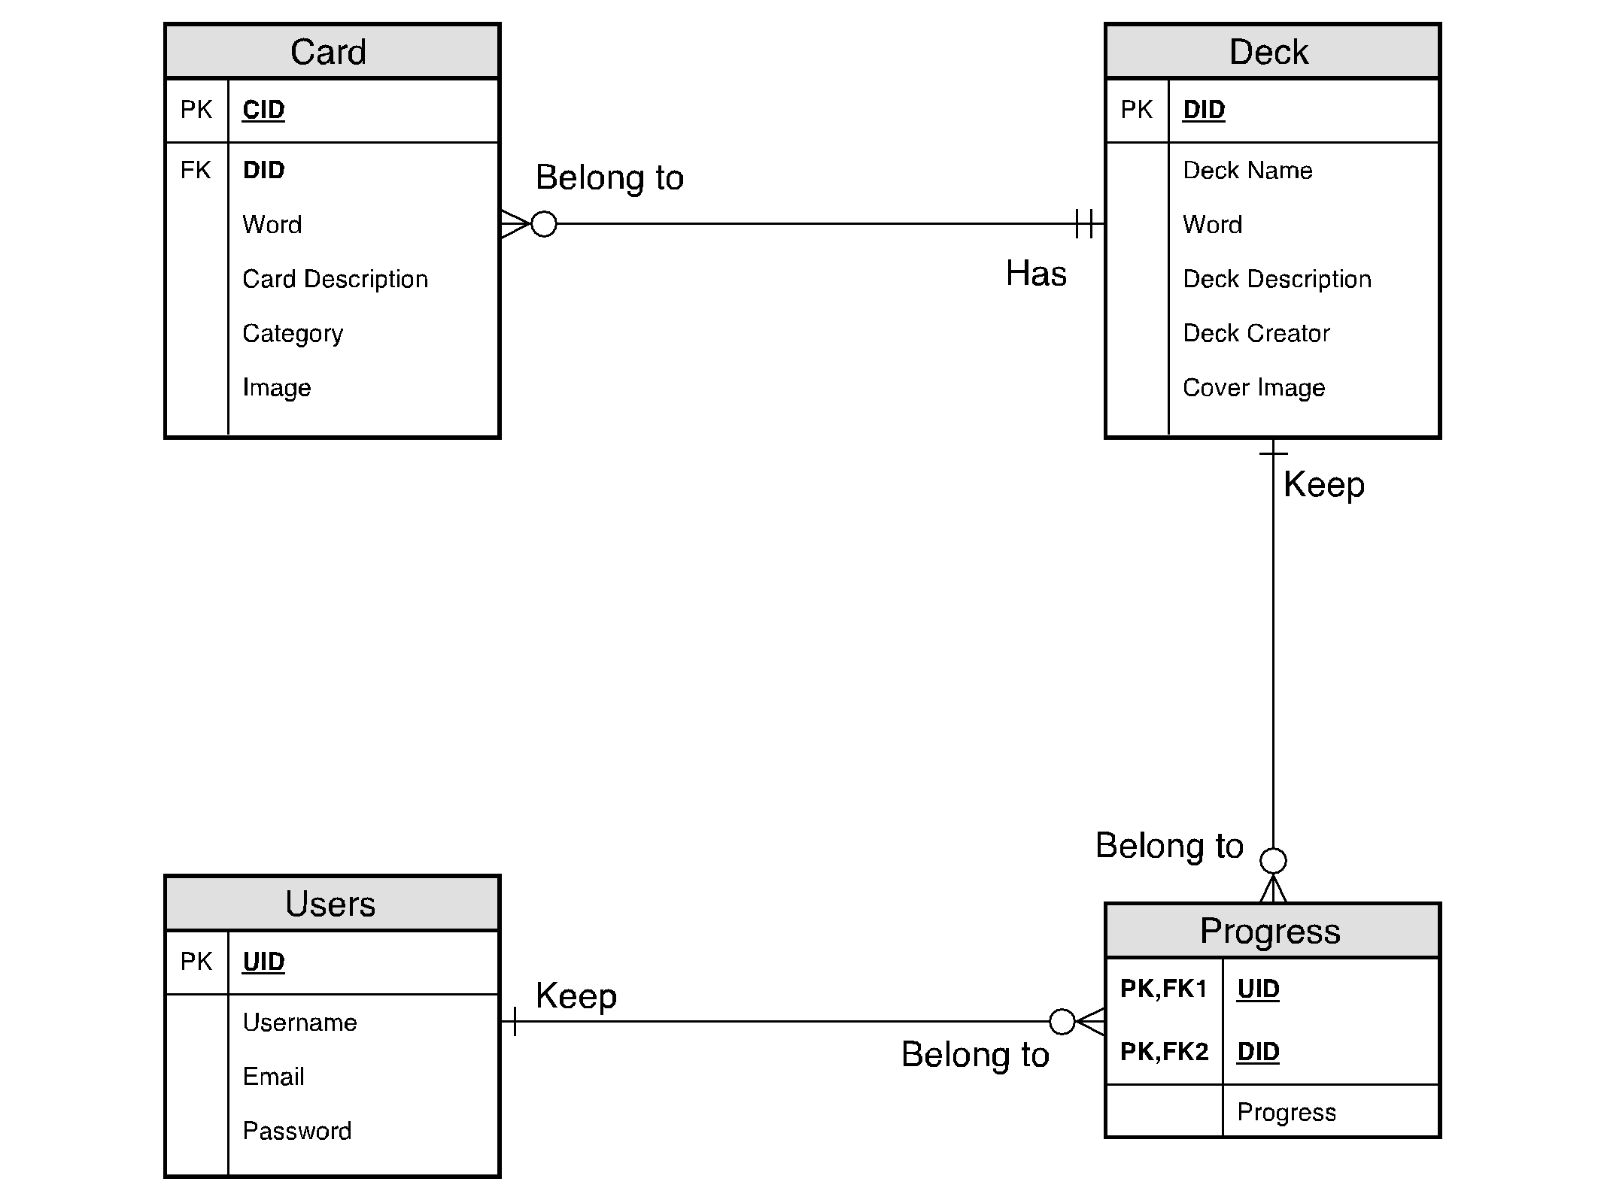

# Screenshots & Pages

index.php

This is the first page of our website. You can login or signup on this page. If you already login, you will be automatically redirect to main.php.

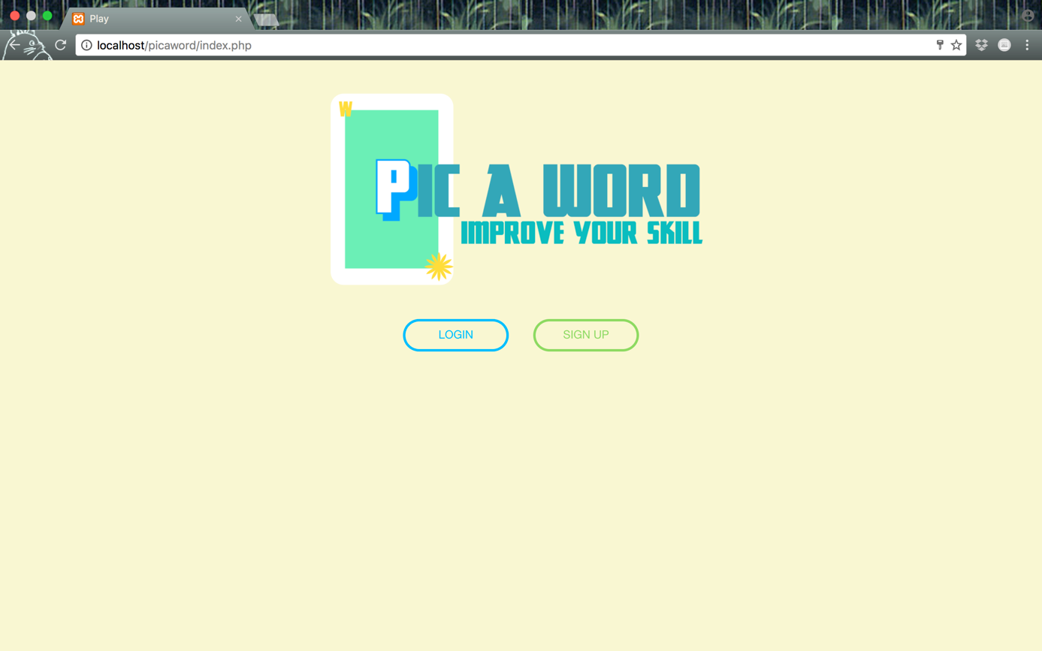

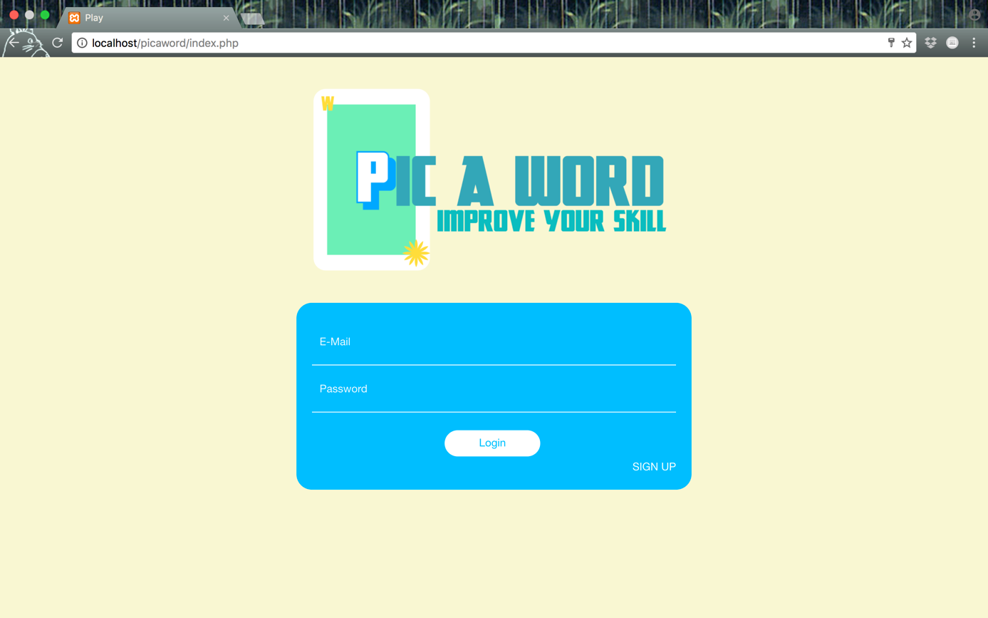

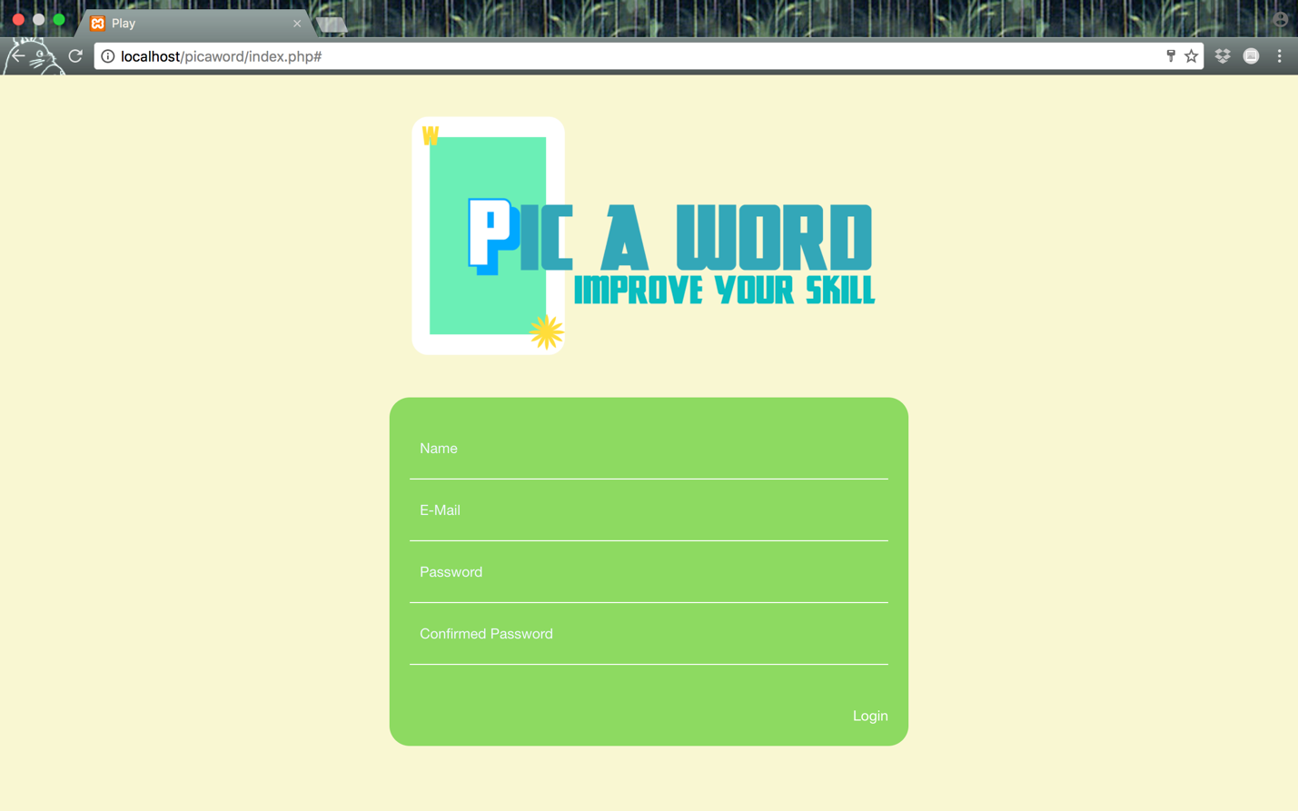

main.php

This is main page of our website. It will list all of decks on our websites. You can add particular deck to your progress decks. Then, you can click on each decks and learn vocabulary from your progress decks by clicking “Learning”. After that, you can challenge yourself by clicking “Play” button to keep your progress by answering word in each cards from particular deck. Moreover, you can remove each decks from your progress decks if you don’t want to learn vocabulary from that deck anymore. In addition, you can logout from our website and go to page that you can create your own deck (adddeck.php) by using a sidebar.

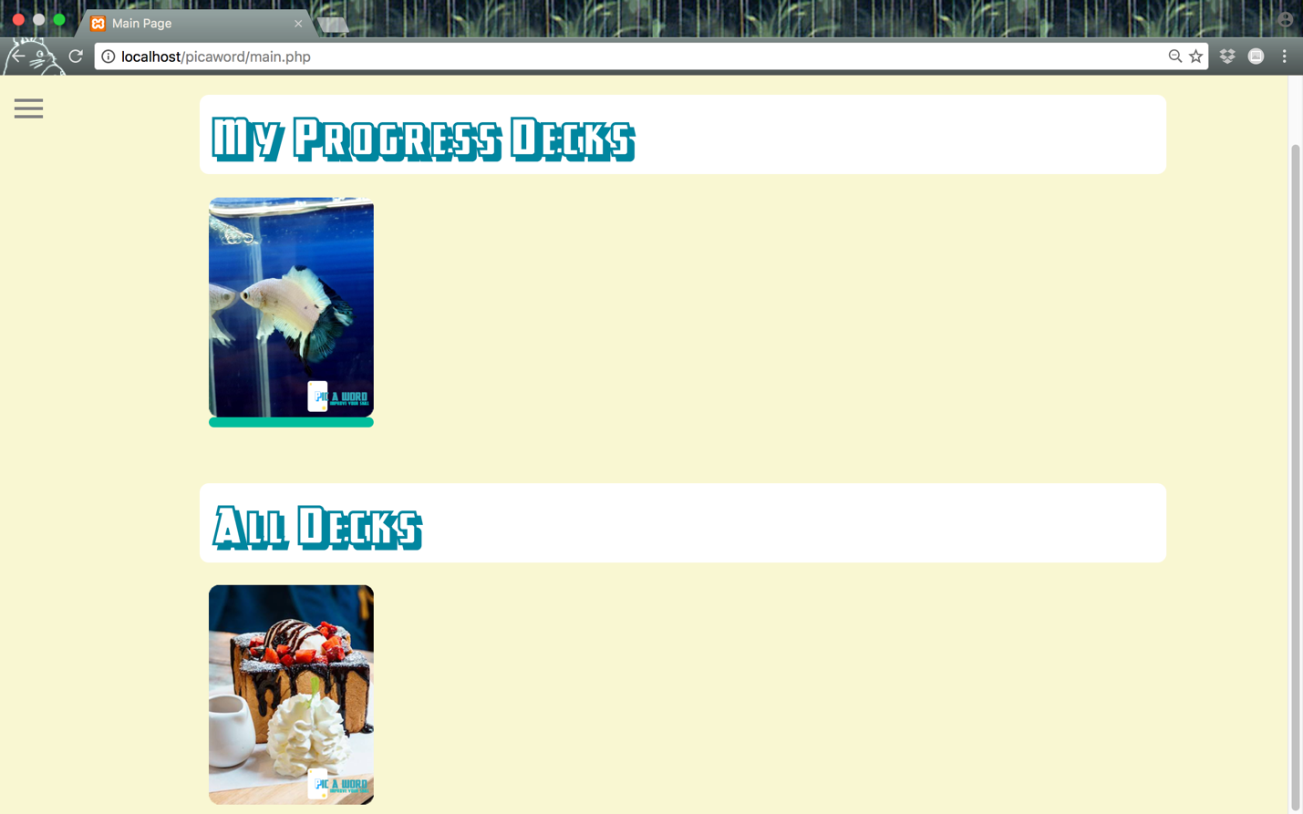

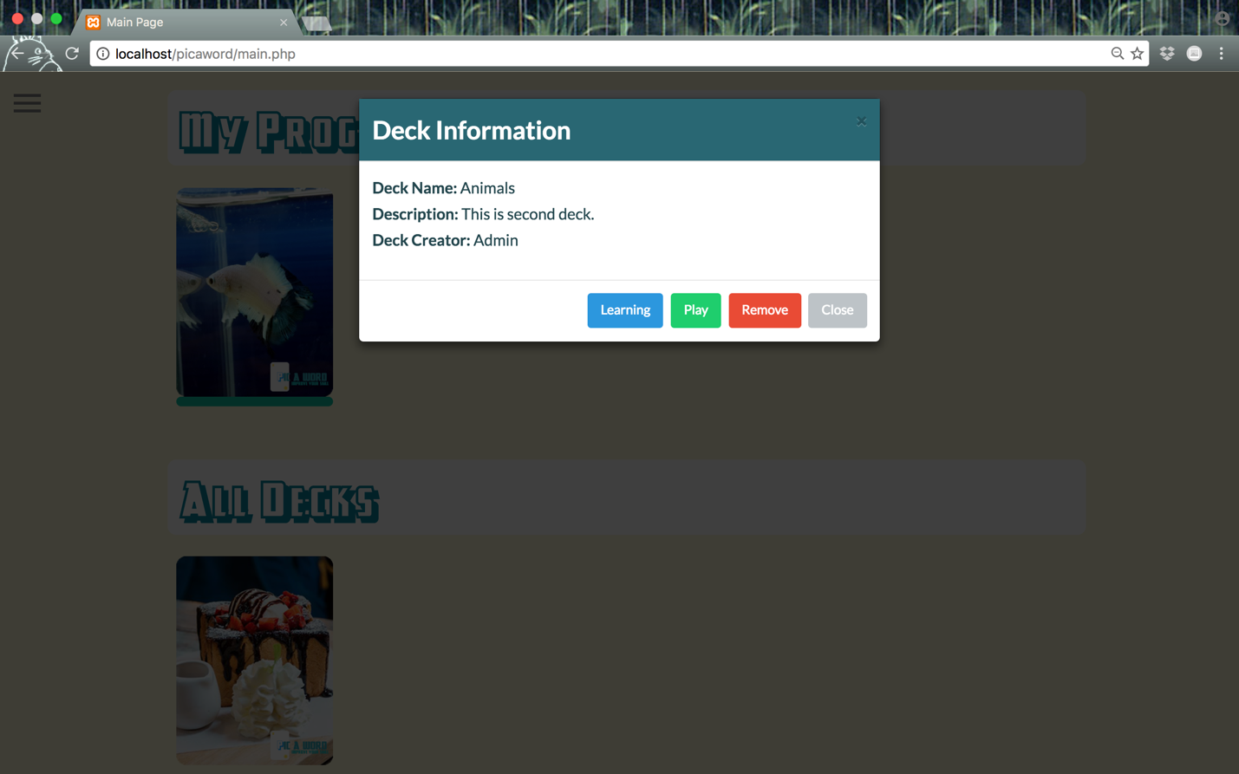

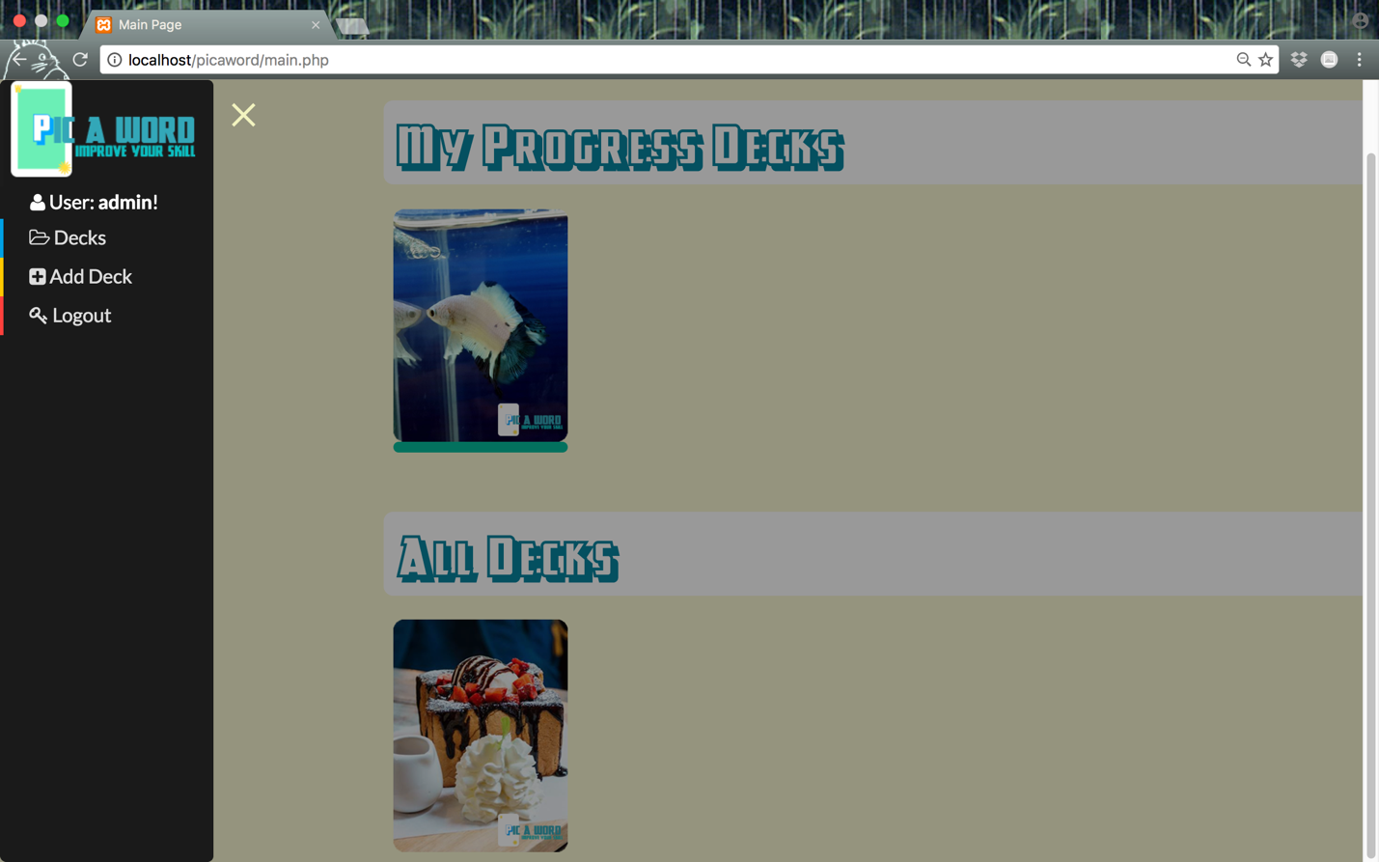

game.php

This page will be the page that you will be able to learn or challenge yourself on each particular deck. You can click on each card and it will be flipped. You will see a word with description of each card. On learning mode, you can click “Next” and “Prev” button to view and memorize all vocabulary in a deck. However, you will see only description when you flipped a card in challenge mode (when you click “Play” button on particular deck in main.php). Morover, You can click “X” button to go back to main.php.

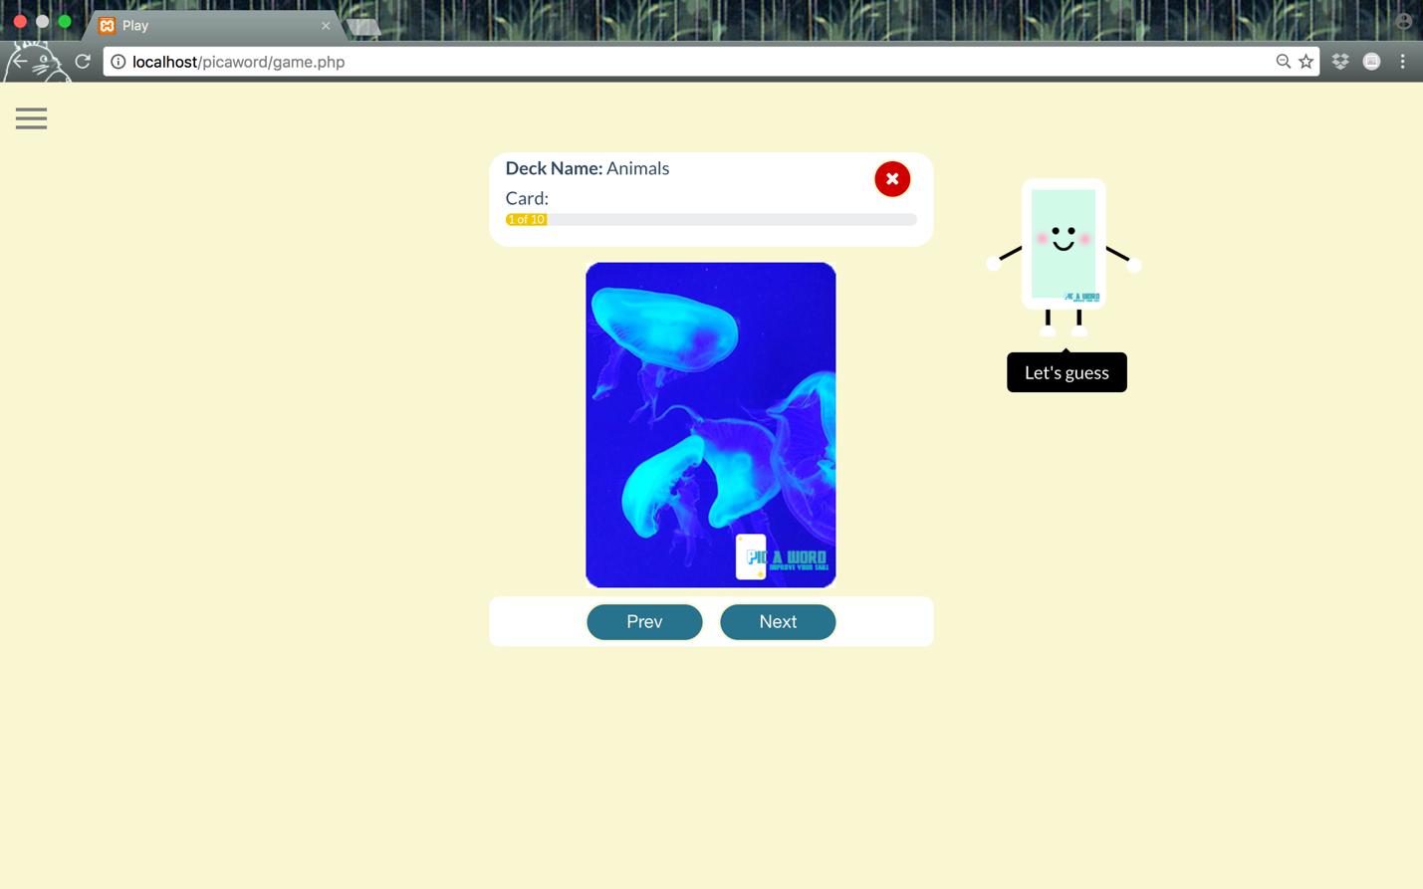

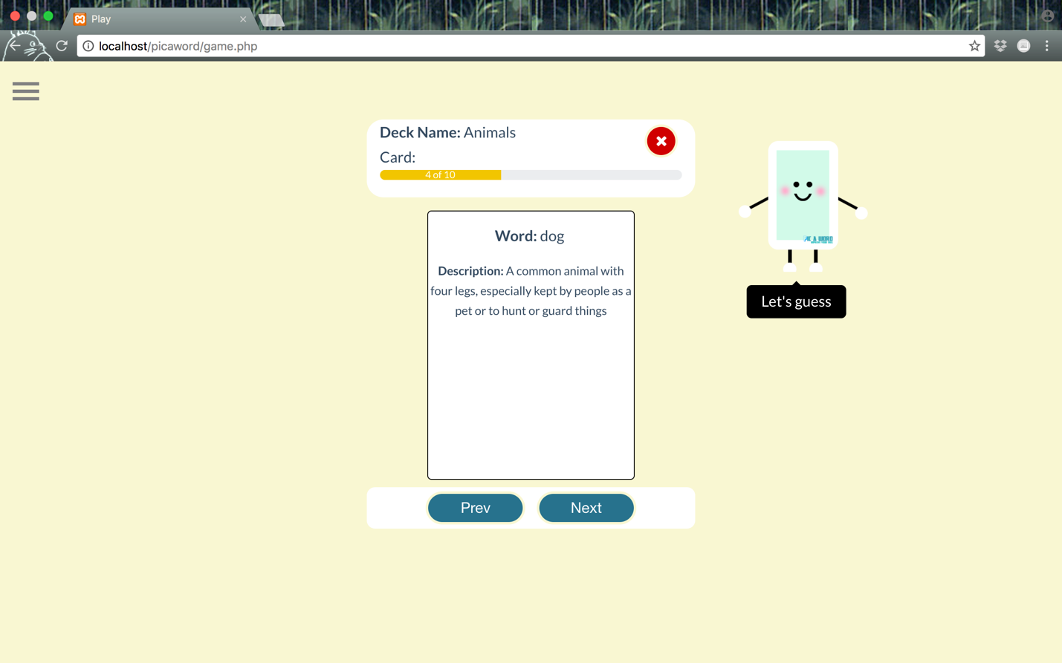

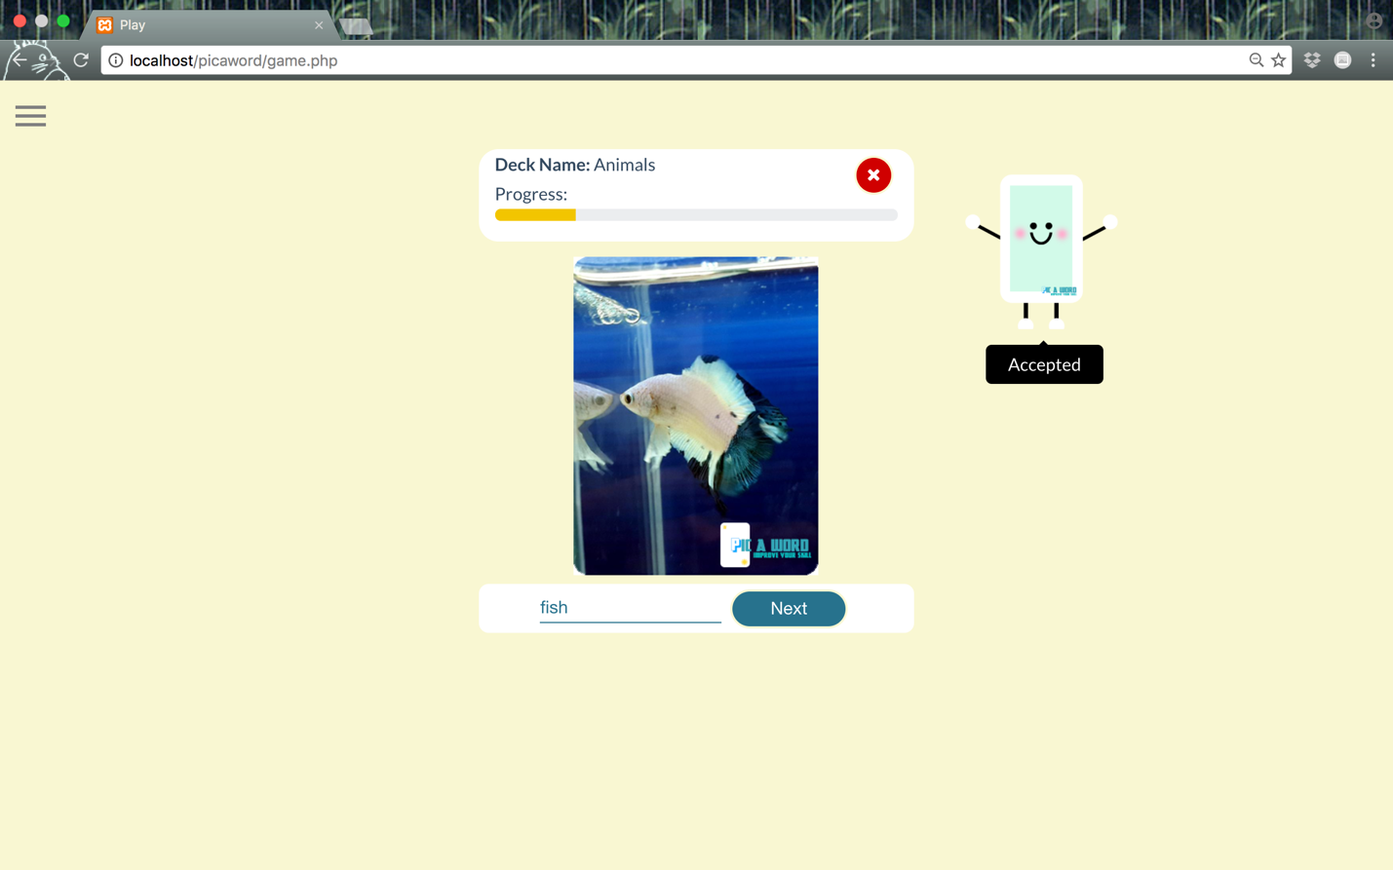

adddeck.php

This page allows you to create your own deck. You have to enter deck name and its description. After that, your created deck will be displayed on the main page. Moreover, you can insert or add card with description and image by clicking on each deck you created and click “Add Card” button.

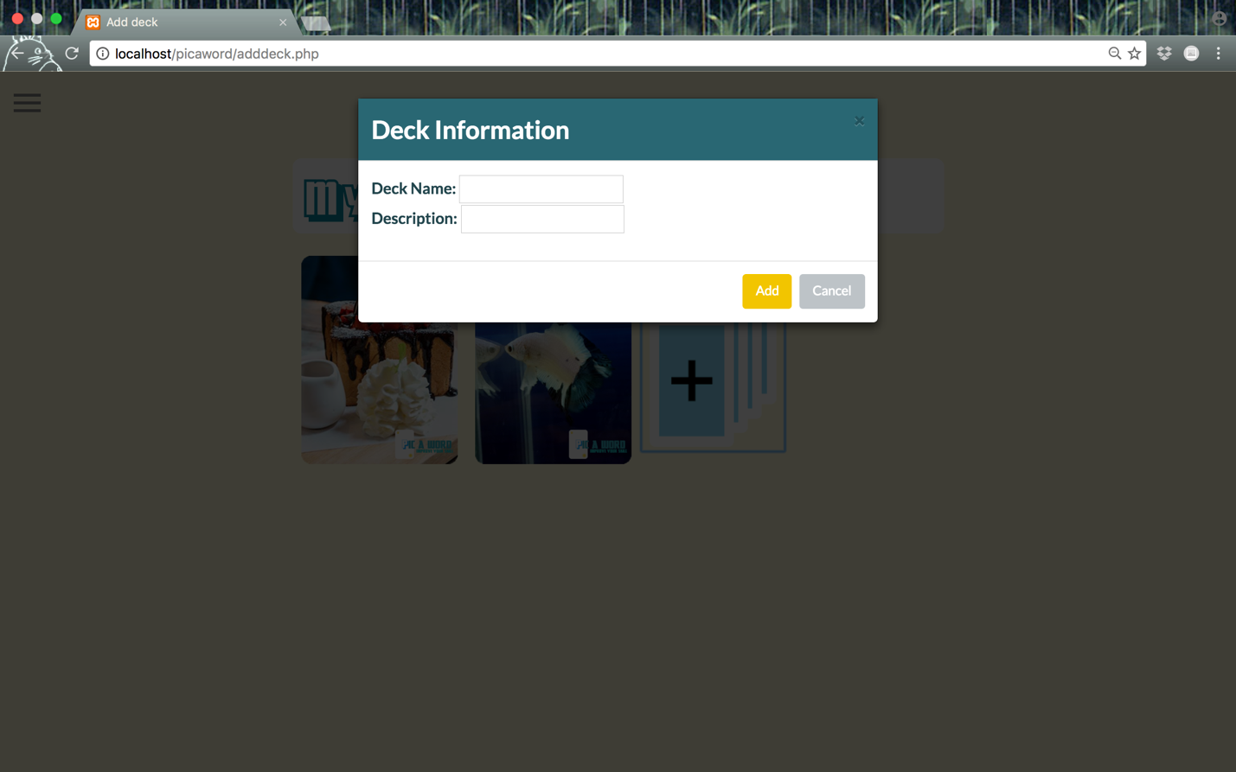

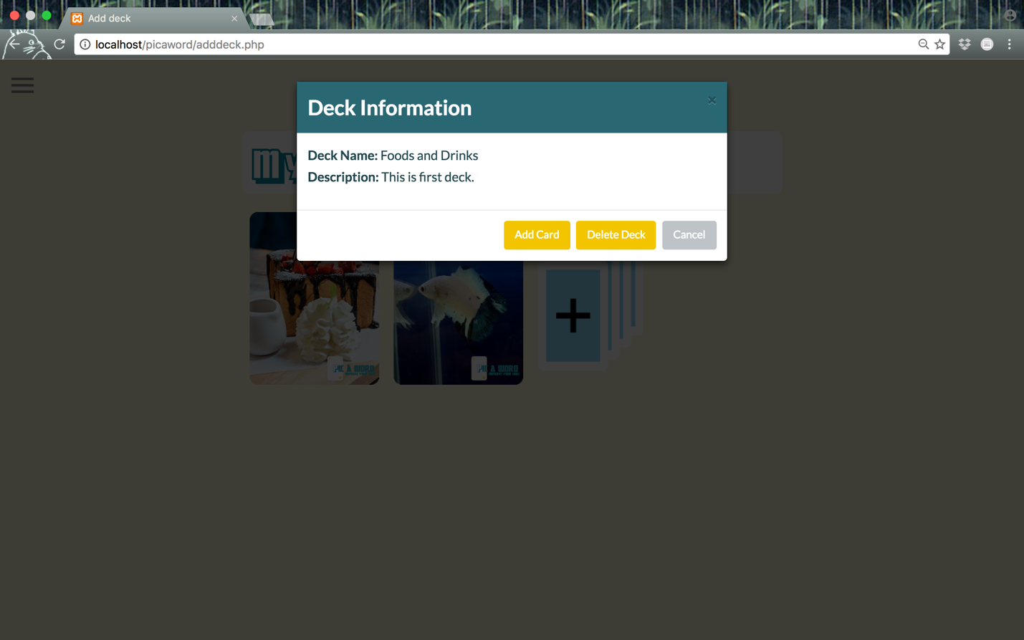

addcard.php

This page allows you to add new card to your deck. You have to fill in card’s name, card’s description, card’s category and upload an image that can represent or give clue of that card. Then, you can click “Add” button to add that card to a deck.

